1. 下列表达式的值是多少？

What is the numerical value of each of the following expressions?

a. 5 > 2

b. 3 + 4 > 2 && 3 < 2

c. x >= y || y > x

d. d = 5 + ( 6 > 2 )

e. 'X' > 'T' ? 10 : 5

f. x > y ? y > x : x > y

a = 1

b = 0

c = 1

d = 6

e = 10

f = 0

2

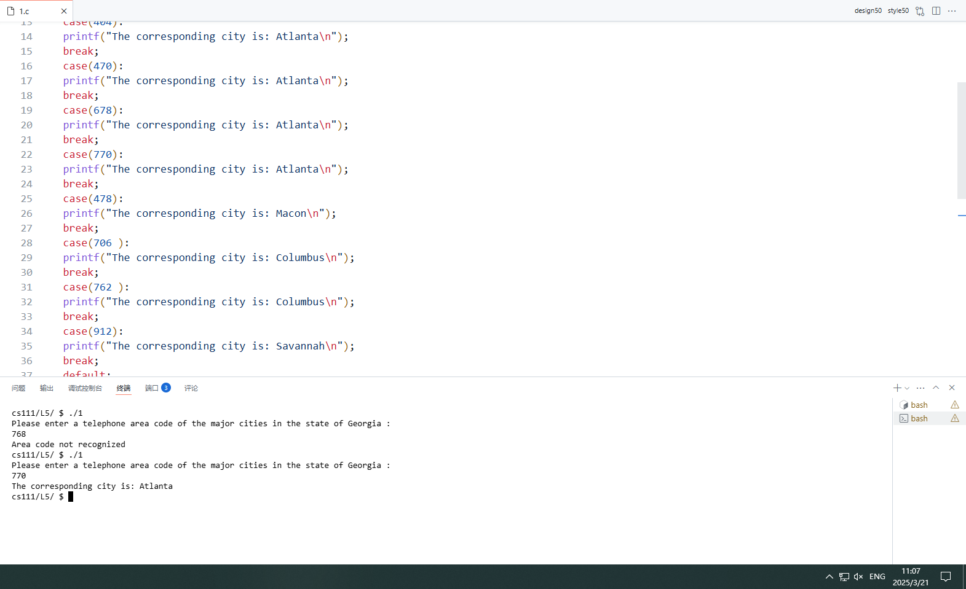

3

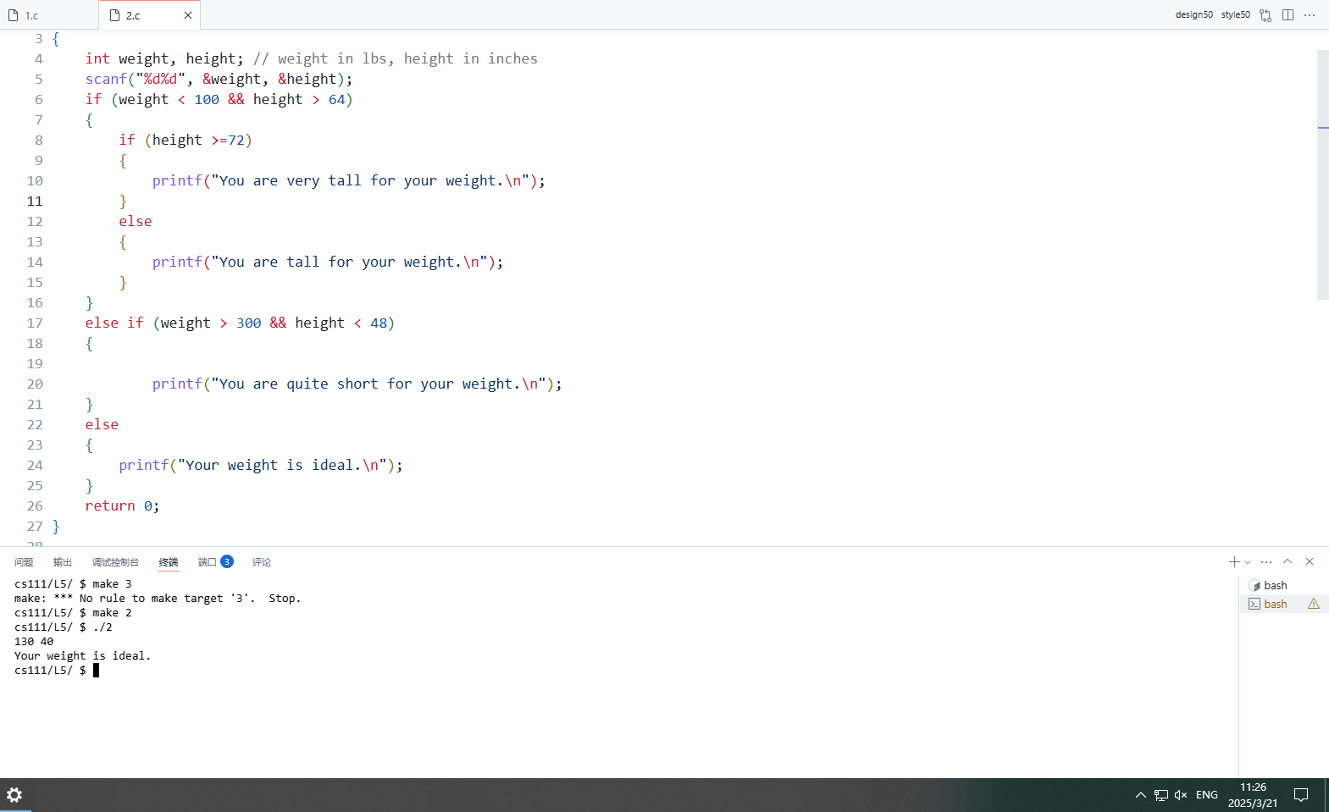

4

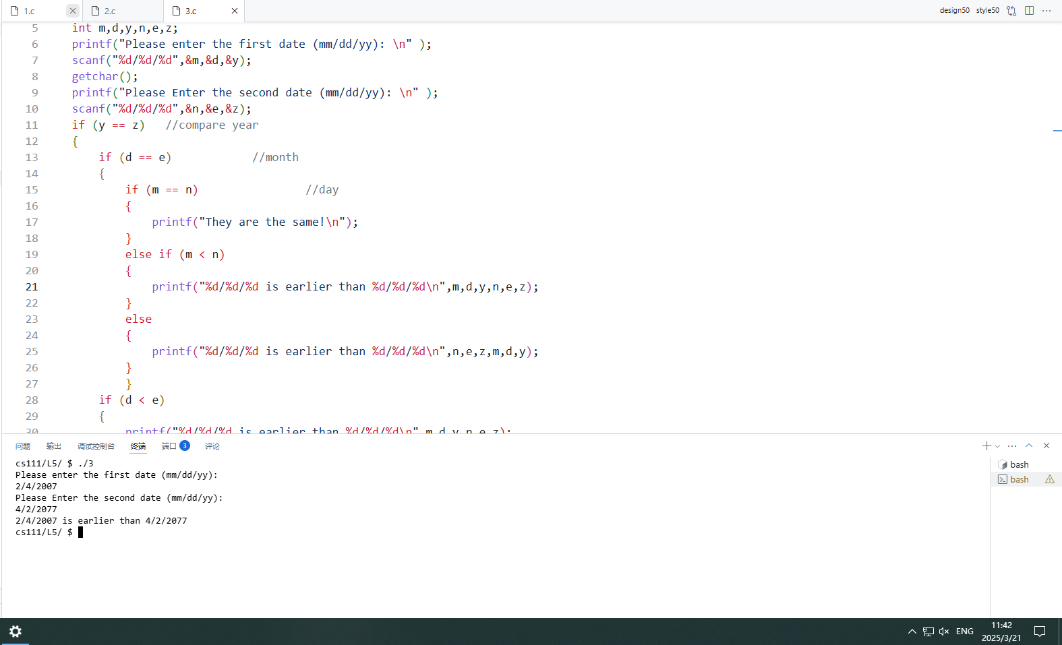

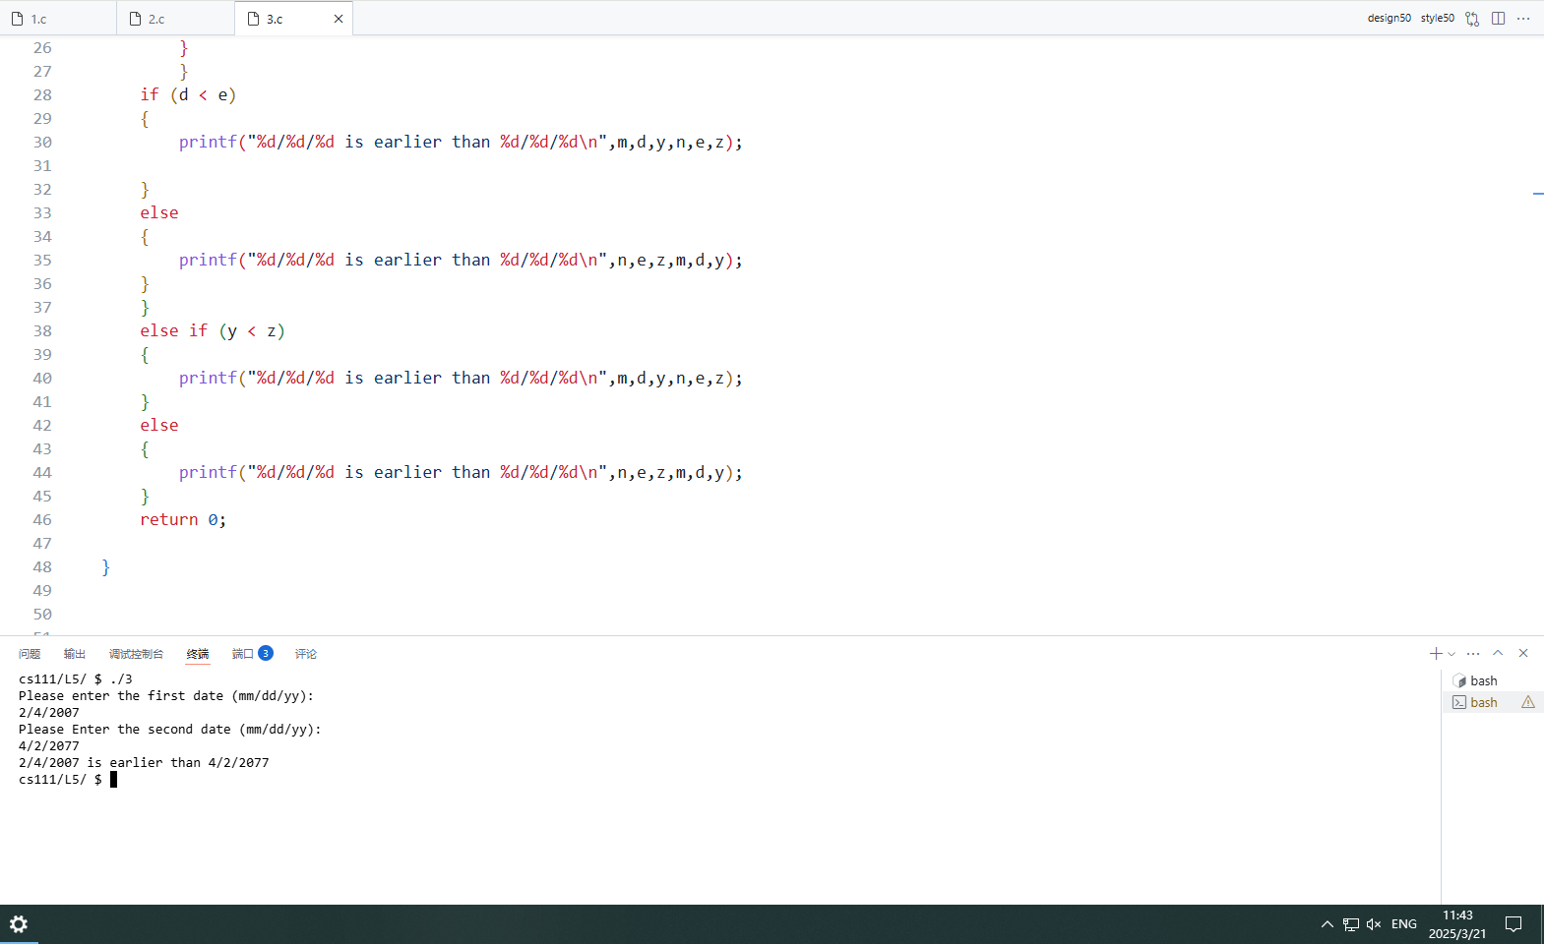

5

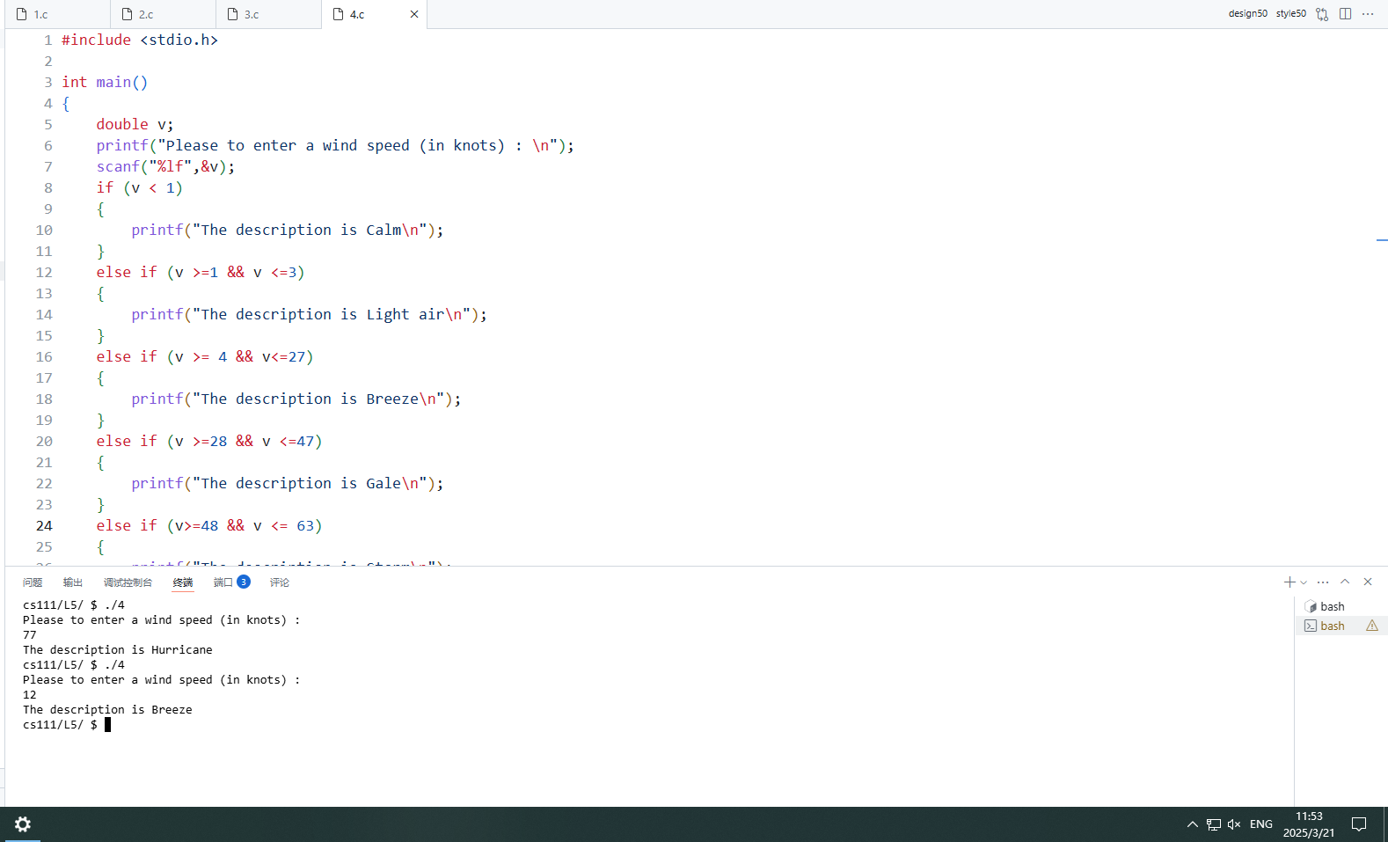

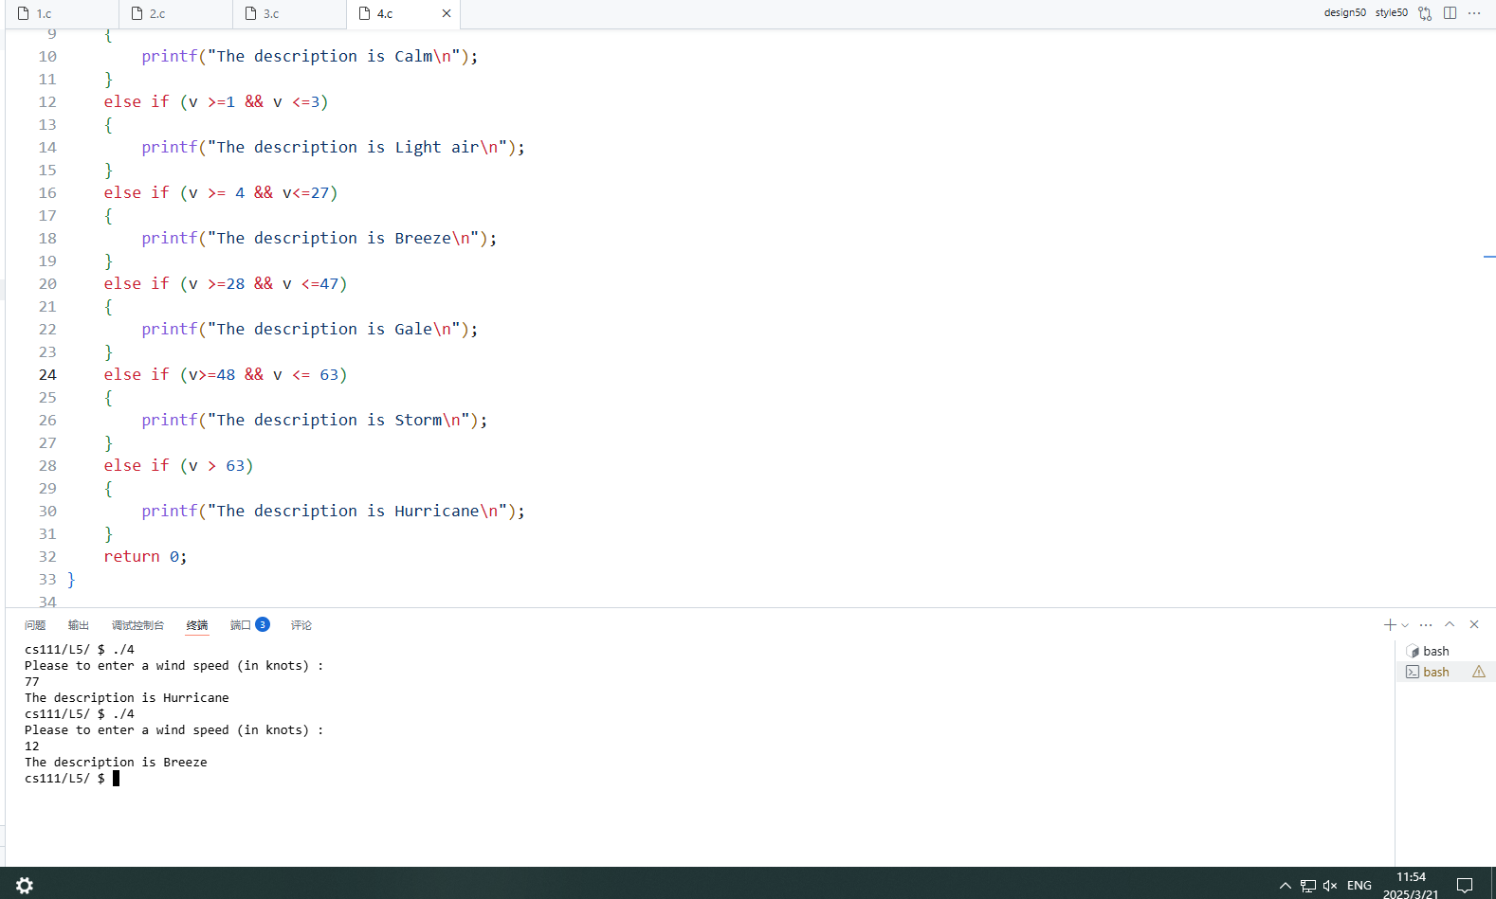

6

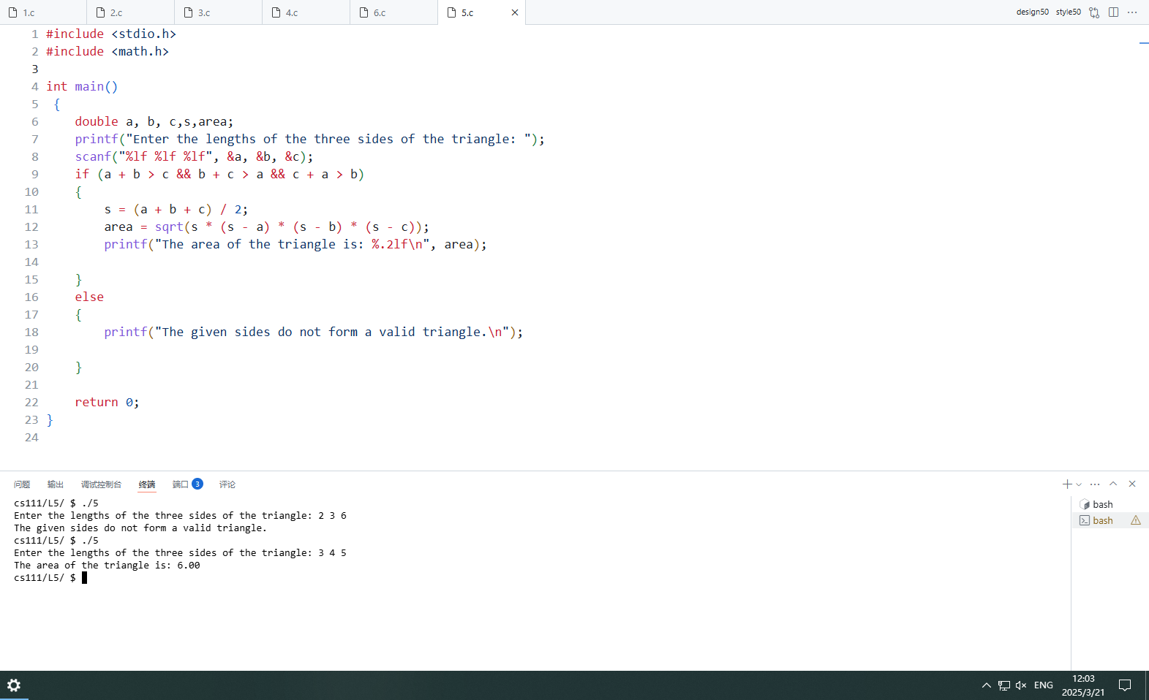

7

